|  |  |  |
| --- | --- | --- |
| A close up of a logo  Description generated with very high confidence |  | |
| Implement flyout for shared mailbox  capacity alert | |
|  | PM: PM name |

## Overview

The Exchange team is creating a new monitoring scenario for shared mailboxes, which will inform customers that they have shared mailboxes that are over capacity. We need to build a flyout to show the customers which shared mailboxes are over capacity. This is very similar to the flyout already implemented for two existing scenarios: mailbox over and archive mailboxes

## Business Justification

Once a shared mailbox reaches 50GB, the tenant should license it or reduce the size, however that’s not enforced, and over 1k mailboxes are out of compliance. This is bad for customers, who generally like to stay compliant, and also represent $1.2M in missed revenue for Microsoft.

## Design Considerations

Model this new Shared Mailbox alert after one of the three existing alerts:

* Mailbox quota: “We’ve detected mailboxes exceeding or at risk of reaching their quota limit” alert:
* Large Archive: “Auto-expanding archive mailbox(es) in your tenant are approaching or have exceeded the 1.5 TB limit”
* Priority account mailbox: “Priority accounts: Mail storage quota limit issue noticed”
* 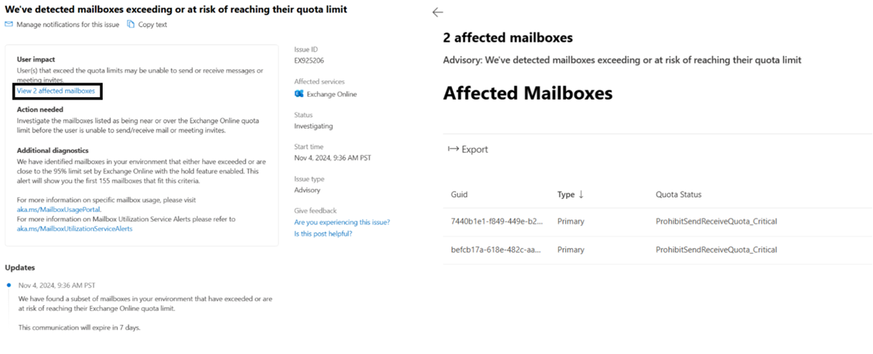

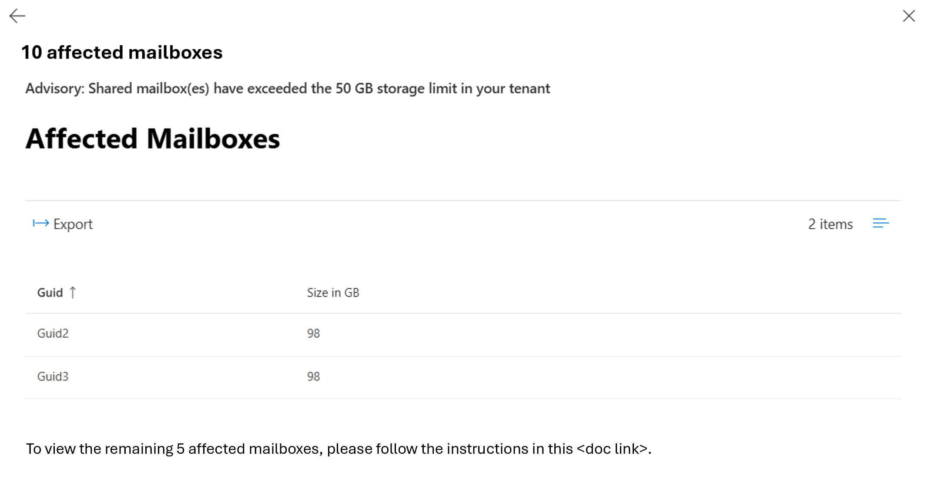

Note: The list of Mailbox GUIDs is part of the TenantListString parameter

**Testing Approach**

1. The Exchange team will create a test post in PPE to allow the flyout UI to be developed and tested:

* Tenant: [Norawit to provide details]
* Testing URL: [Norawit to provide details]

1. After the flyout code ships to production, the Exchange team will create a test post in production, targeted to the tenant, so it can be tested there.

* Tenant: RDXSHDMCTest.onmicrosoft.com
* Testing url: admin-ignite.microsoft.com

1. Lastly the Exchange team will activate the monitoring feature so alert will be sent out to customers automatically.